**Data Mining Assignment 2**

**Training and Testing Data:**

We have divided our dataset into two parts :

1.Training Data

2.Testing Data

Using Stratified Sampling with ratio of 0.7

The following is the decision tree obtained: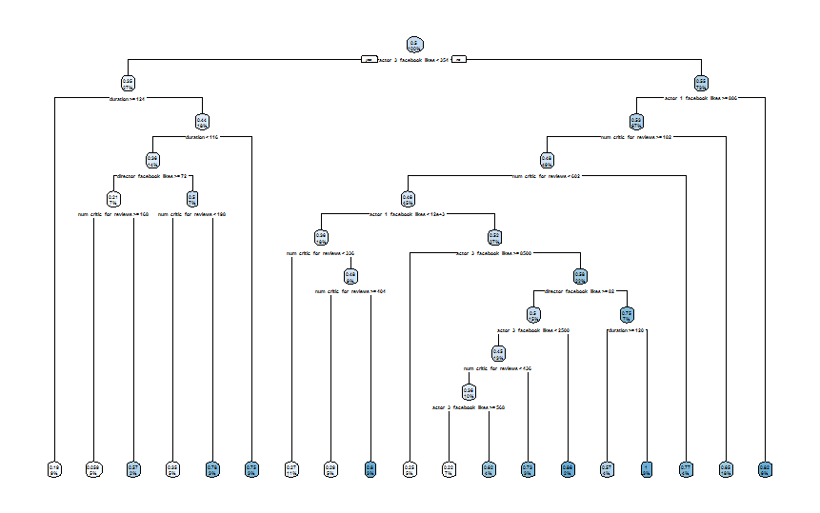

After that we have compared the result obtained from ID3 algorithm with the testing data. Then we obtained a confusion matrix by which we can identify the efficiency of the algorithm.

Confusion Matrix and Statistics

Reference

Prediction 0 1

0 45 31

1 39 35

Accuracy : 0.5333

95% CI : (0.4502, 0.6151)

No Information Rate : 0.56

P-Value [Acc > NIR] : 0.7708

Kappa : 0.0652

Mcnemar's Test P-Value : 0.4028

Sensitivity : 0.5357

Specificity : 0.5303

Pos Pred Value : 0.5921

Neg Pred Value : 0.4730

Prevalence : 0.5600

Detection Rate : 0.3000

Detection Prevalence : 0.5067

Balanced Accuracy : 0.5330

'Positive' Class : 0

Team Members:

1.Nadimpalli Sri Harsha(14UCS074)

2.Ankit Gupta(14UCC006)

3.Lovish Jain(14UCC018)